Imbalanced Classification Problems:

Standard classifier algorithms like Decision Tree and Logistic Regression have a bias towards classes which have number of instances. They tend to only predict the majority class data.

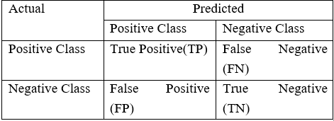

Approaches to handle this scenario:

Improving classification algo/ Balancing classes in training data

Resampling Techniques: Balancing classes in training data

1. Under Sampling: Randomly eliminating majority class examples. Information Loss, The sample chosen may become a biased sample
2. Overdsampling : increases the number of instances in the minority class by randomly replicating them in order to present a higher representation of the minority class in the sample. No Information Loss but increases the likelihood of overfitting since it replicates minority class events.
3. Cluster Based over sampling: In this case, the K-means clustering algorithm is independently applied to minority and majority class instances. This is to identify clusters in the dataset. Subsequently, *each cluster is oversampled such that all clusters of the same class have an equal number of instances and all classes have the same size. But the problem of overfitting still exists!!*
4. Synthetic Minority over sampling techniques: This technique is followed to avoid overfitting which occurs when **exact replicas of minority instances** are added to the main dataset. Mitigates overfitting problem. But While generating synthetic examples SMOTE does not take into consideration neighboring examples from other classes. This can result in increase in overlapping of classes and can introduce additional noise
5. Modified SMOTE:

Modifying existing classification algorithms to make them appropriate for imbalanced data sets.

Bagging algorithm involves generating ‘n’ different bootstrap training samples **with replacement.**

Bagging is used for reducing Overfitting in order to create strong learners for generating accurate predictions. Unlike boosting, bagging allows replacement in the bootstrapped sample. Each sample is different from the original dataset but resembles the dataset in **distribution & variability.** It improves stability, reduces variance, overcome overfitting!!

Boosting:

Boosting is an ensemble technique to combine weak learners to create a strong learner that can make accurate predictions. A classifier learning algorithm is said to be weak when small changes in data induce big changes in the classification model.



XGBoost:

It is 10 times faster than the normal Gradient Boosting as it implements parallel processing. It is highly flexible as users can define custom optimization objectives and evaluation criteria, has an inbuilt mechanism to handle missing values.

Unlike gradient boosting which stops splitting a node as soon as it encounters a negative loss, XG Boost splits up to the maximum depth specified and prunes the tree backward and removes splits beyond which there is an only negative loss.

**Different File Formats in Python**

A file format is a standard way in which information is **encoded** for storage in a file.

First, the file format specifies whether the file is a **binary or ASCII** file. Second, it shows how the information is **organized**.

1. Comma-separated values
2. XLSX
3. ZIP
4. Plain Text (txt)
5. JSON
6. XML
7. HTML
8. Images
9. Hierarchical Data Format
10. PDF
11. DOCX
12. MP3
13. MP4

As a data scientist, you need to understand the underlying structure of various file formats, their advantages and dis-advantages. Unless you understand the underlying structure of the data, you will not be able to explore it.

Record--🡪 Columns

In Python:

import pandas as pd

1. df = pd.read_csv(“/home/Loan_Prediction/train.csv”)
2. XLSX (Microsoft Excel Open XML format)



df = pd.read_excel(“/home/Loan_Prediction/train.xlsx”, sheetname = “Invoice”)

1. ZIP files (Zip RAR, Tar)

import zipfile

archive = zipfile.ZipFile('T.zip', 'r')

df = archive.read('train.csv')

1. Txt file-The txt file format can easily be read by any program. But interpreting this is very difficult by a computer program.

text_file = open("text.txt", "r")

lines = text_file.read()

1. JSON

JavaScript Object Notation(JSON) is a text-based open standard designed for exchanging the data over web. JSON format is used for transmitting structured data over the web. The JSON file format can be easily read in any programming language because it is language-independent data format.

df = pd.read_json(“/home/ /Loan_Prediction/train.json”)

1. XML Format

It is a markup language, both human and machine readable. It is desgined for sending information over the internet.

Let’s import an xml file called train and print its root tag.

import xml.etree.ElementTree as ET

tree = ET.parse('/home/sunilray/Desktop/2 sigma/train.xml')

root = tree.getroot()

print root.tag

1. HTML

HTML tags are same as XML but **these are predefined**. You can easily identify HTML document subsection on basis of tags such as <head> represent the heading of HTML document. <p> “paragraph” paragraph in HTML.

1. Image Files

Usual image files are 3-Dimensional, having RGB values. But, they can also be 2-Dimensional (grayscale) or 4-Dimensional (having intensity) – an Image consisting of pixels and meta-data associated with it. Each image consists one or more frames of pixels. And each frame is made up of two-dimensional array of pixel values. Pixel values **can be of any intensity**.  **Meta-data associated with an image, can be an image type (.png) or pixel dimensions.**

from scipy import misc

f = misc.face()

misc.imsave('face.png', f) # uses the Image module (PIL)

import matplotlib.pyplot as plt

plt.imshow(f)

plt.show()

1. MP3 FORMAT

In multimedia file formats, you can store variety of data such as text image, graphical, video and audio data.

A mp3 file format uses the MPEG-1 (***Moving Picture Experts Group – 1***) encoding format which is a standard for **lossy compression of video and audio**. In lossy compression, once you have compressed the original file, you cannot recover the original data.

A mp3 file is made up of several frames. A frame can be further divided into a header and data block. We call these sequence of frames an elementary stream.

1. DOCX Format

pip install docx2txt

import docx2txt

text = docx2txt.process("file.docx")

**Image Processing**

If you can create an application of auto-tagging a photograph as that of Facebook, or create your own face recognition password to your laptop.

Skimage package enables us to do image processing using Python.

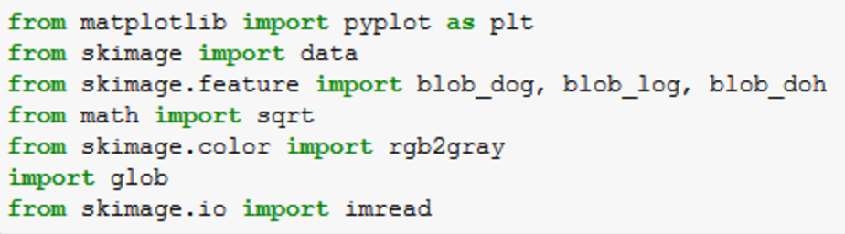

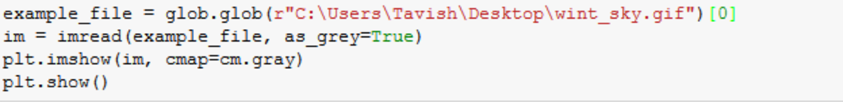

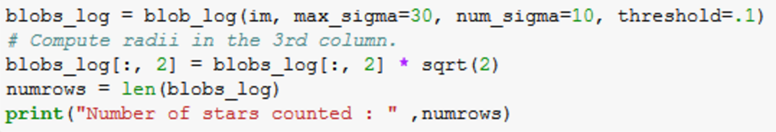

These few command go out for **searching continuous objects** in the picture. Blobs_log gives three outputs for each object found. **First two are the coordinates and the third one is the area of the object.** The radius of each blob/object can be estimated using this column (area of the object).

The number 308 is still coming out of a black box. Let’s look at whether we have spotted all the stars correctly. For this I am circling each estimated star position. And the look at the image if we are missing any star.

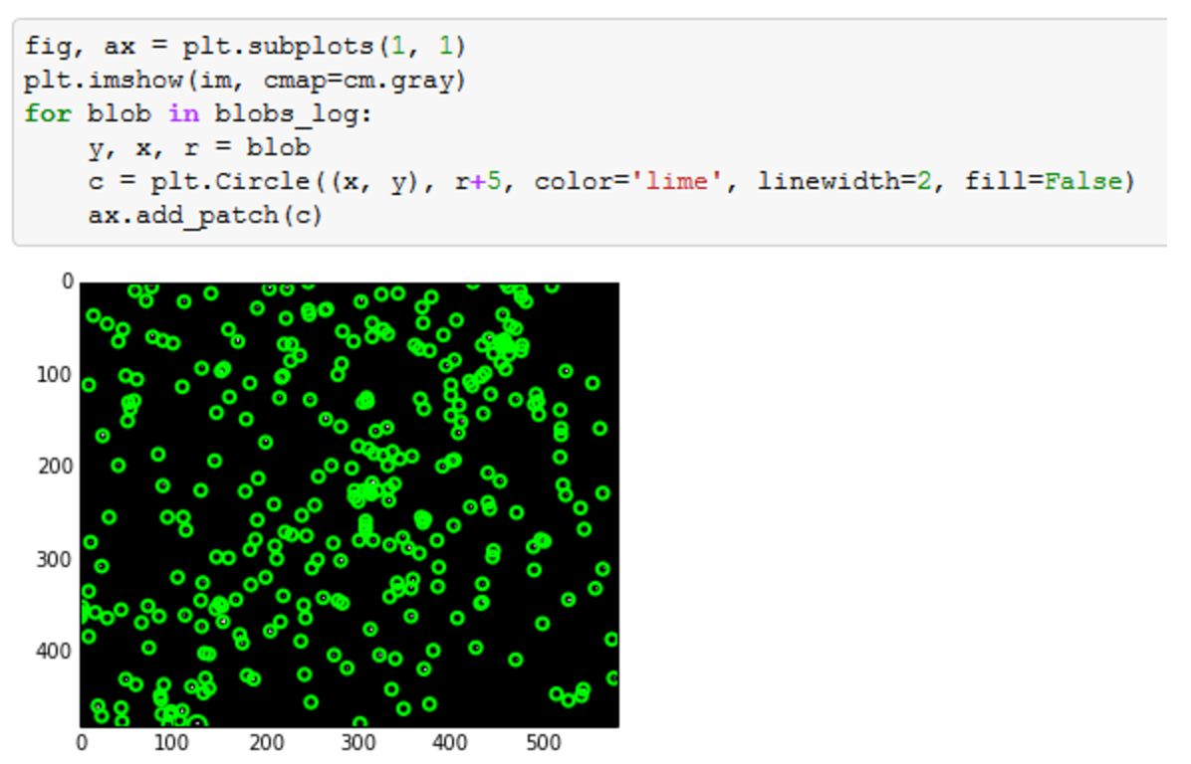

<https://www.analyticsvidhya.com/blog/2015/01/basics-image-processing-feature-extraction-python/>

we rarely wonder how are these pictures stored in memory or how are the various transformations made in a photograph.

Image Processing- Feature Extraction and data cleaning

how an image is stored on a disc and how we can manipulate an image using this underlying data?

Image might have several colors and many pixels.

Storage? Each pixel can be considered as a cell.Each cell contains 3 different colors- RGB-leading to a 3D Matrix. Each number is the intensity of Red, Blue, Green colors.

Converting images into 2D matrix

Handling the third dimension of images sometimes can be complex and redundant. **In feature extraction**, it becomes much simpler if we compress the image to a 2-D matrix. This is done by Gray-scaling or Binarizing.

Gray scaling is richer than Binarizing as it shows the image as a combination of different intensities of Gray. Whereas binarzing simply builds a matrix full of 0s and 1s.

the dimension of the image has been reduced to two in Grayscale. However, the features are equally visible in the two images. This is the reason why Grayscale takes much lesser space when stored on Disc.

Binarizing the image:

This is done by finding a threshold and flagging the pixels of Grayscale. Can use Otsu’s method to find the threshold. Otsu’s method calculates an “optimal” threshold by maximizing the variance between two classes of pixels, which are separated by the threshold. Equivalently, this threshold minimizes the intra-class variance.

RGB>Grayscale>Binarizing>Blurring

Blurring an image:

Blurring algorithm takes weighted average of neighbouring pixels to incorporate surroundings color into every pixel. Following is an example of blurring :

Bluring is used to equalize the intensity overall!!

rom skimage.color import rgb2gray

gray_image = rgb2gray(image)

show_images(images=[image,gray_image],titles=["Color","Grayscale"])

print "Colored image shape:", image.shape

print "Grayscale image shape:", gray_image.shape

from skimage.filter import threshold_otsu

thresh = threshold_otsu(gray_image)

binary = gray_image > thresh

show_images(images=[gray_image,binary_image,binary],titles=["Grayscale","Otsu Binary"])

from skimage.filter import gaussian_filter

blurred_image = gaussian_filter(gray_image,sigma=20)

show_images(images=[gray_image,blurred_image],titles=["Gray Image","20 Sigma Blur"])

Feature extraction from image:

include detecting corners, segmenting the image, seperating object from the background etc.

**Python Learning**

1. Apply function

def num_missing(x): return sum(x.isnull()) data.apply(num_missing, axis=0) #axis=0 defines that function is to be applied on each column

1. Pivot

Pivot_table (values=["LoanAmount"], index=["Gender","Married","Self_Employed"], aggfunc=np.mean)

**Categorical Missing values**

* A categorical variable has too many levels. This pulls down performance level of the model. For example, a cat. variable “zip code” would have numerous levels.
* A categorical variable has levels which rarely occur. Many of these levels have minimal chance of making a real impact on model fit. For example, a variable ‘disease’ might have some levels which would rarely occur.
* There is one level which always occurs i.e. for most of the observations in data set there is only one level. Variables with such levels fail to make a positive impact on **model performance due to very low variation.**
* If the categorical variable is masked, it becomes a laborious task to decipher its meaning. Such situations are commonly found in [data science competitions](http://datahack.analyticsvidhya.com/).
* You can’t fit categorical variables into a regression equation in their raw form. They must be treated.
* Most of the algorithms (or ML libraries) produce better result with numerical variable. In python, library “sklearn” requires features in numerical arrays. Look at the below snapshot. I have applied random forest using sklearn library on titanic data set (only two features sex and pclass are taken as independent variables). It has returned an error because feature “sex” is categorical and has not been converted to numerical form

A common challenge with nominal categorical variable is that, it may decrease performance of a model. For example: We have two features “age” (range: 0-80) and “city” (81 different levels). Now, when we’ll apply label encoder to ‘city’ variable, it will represent ‘city’ with numeric values range from 0 to 80. The ‘city’ variable is now similar to ‘age’ variable since both will have similar data points, which is certainly not a right approach.

**Quora Question Pairs:**

Multiple questions with the same intent can cause seekers to spend more time finding the best answer to their question. Quora uses a Random Forest model to identify duplicate questions. In this competition, Kagglers are challenged to tackle this natural language processing problem by applying advanced techniques to classify whether question pairs are duplicates or not. Doing so will make it easier to find high quality answers to questions resulting in an improved experience for Quora writers, seekers, and readers.

Methods used and to be learnt:

TF-IDF, Singular Value Decomposition, Fuzzy Features, Word2Vec features, GloVe features, LSTMs and 1D CNN.

Variables used:

Avg number characters in Q1

Min number of characters in Q1

Max number of characters in Q1

Avg number characters in Q2

Min number of characters in Q2

Max number of characters in Q2

Length of Q1

Length of Q2

Difference in two lengths

Character length of Q1 without spaces

Character length of Q2 without spaces

Number of words in Q1

Number of words in Q2

Number of common words in Q1 and Q2

Pandas Apply functions:

Fuzzy Features using fuzzy package:

QRatio

WRatio

Partial Ratio

Partial token set ratio

Partial token sort ratio

Token set ratio

Token sort ratio

TF_IDF and SVD(Singular value decomposition) features



Word2Vec Features

Word2Vec creates a multi-dimensional vector for every word in the english vocabulary. what these embeddings are and how they are generated?

Word2Vec can be used to represent words and words which have similar meaning will be very close to each other in the word2vec space. An example has been shown in the following figure:

Installing xgboost in python:

<https://www.ibm.com/developerworks/community/blogs/jfp/entry/Installing_XGBoost_on_Mac_OSX?lang=en>



Word Mover’s distance: uses word2vec embeddings and works on a principle similar to that of earth mover’s distance to give a distance between two text documents. In simple words, word mover’s distance provides the minimum distance needed to “move” a word from one document to another document.

1. Word mover distance
2. Normalized word mover distance
3. Cosine distance between vectors of question1 and question2
4. Manhattan distance between vectors of question1 and question2
5. Jaccard similarity between vectors of question1 and question2
6. Canberra distance between vectors of question1 and question2
7. Euclidean distance between vectors of question1 and question2
8. Minkowski distance between vectors of question1 and question2
9. Braycurtis distance between vectors of question1 and question2
10. Skew of vector for Q1
11. Skew of vector for Q2
12. Kurtosis vector for Q1
13. Kurtosis vector for Q2

Build Logistic Model: The data was normalized using z score scaling

different deep learning models, from simple network with dense layers only to LSTM, GRU and 1D CNN.

LogLoss Metric:

In plain English, this error metric is used where contestants have to predict that something is true or false with a probability (likelihood) ranging from definitely true (1) to equally true (0.5) to definitely false(0). The use of log on the error provides extreme punishments for being both confident and wrong. In the worst possible case, a single prediction that something is definitely true (1) when it is actually false will add infinite to your error score and make every other entry pointless.

Feature Selection

<http://scikit-learn.org/stable/modules/feature_selection.html>

Univariate feature selection works by selecting the best features based on univariate statistical tests

Bootstrap

To sample n examples with replacement from the total N.

How we overfit unsupervised learning

evaluate the clustering model using “adjusted rand score”.

Larger k value **means less bias** towards overestimating the true expected error

More data points—less variance

More features—less bias

Underfitting-Increase the complexity of model

Overfitting-Decrease the complexity of model

Increasing penalty factor🡪 Making the decision boundary more complex

Low Penalty factor—Overfit

High gamma value—Overfit

Hidden Markov Models can be applied for any type of time series dataset

1. Random Forest is based on bagging whereas Gradient Boosting is based on boosting. Incase of boosting intermediate trees are not independent of each other because result of previous tree is used by next tree but in case of bagging they are independent.

**Fresh start: 10/09/2017**

<https://github.com/rhiever/tpot/blob/master/tutorials/Titanic_Kaggle.ipynb>

TPOT allows to use GA to select best features and do predictions

* The various flavors of RNN - LSTM, GRU only differ in the way the past is remembered. For instance, it is useful is in some use cases like sentiment analysis to remember what was said at the beginning of the sentence, because that makes the rest of the sentence secondary (*e.g. “I like this movie very much < then a detailed plot description>” follows - the first part matters most. Or the other way around “ <a long plot> followed by this movie sucks”*). These flavors of RNN have ways to remember or forget the past based on the sentence, and this itself can be learnt from training data.

11/09/2017

**Tuning and CV strategy for XGB:**

Typically, people use 5 folds. You can make a choice. To see the reliability of CV estimate, a few guys use 10-fold as well.

**Steps:**

1. Decide 'n' in n-fold. Stick to it for complete analysis.
2. Create a baseline score using a simple model.
3. Now, use XGBoost default settings and establish another XGB baseline score.
4. Put num_trees at 10000 and a tiny learning rate of 0.01.
5. Try step(4) for various max_depth.
6. While doing step(4), monitor the progress. Note at what tree# is the model overfitting
7. After you're done with 1-6, you would have reached a saturation score
8. Now comes some magic! Start using subsample and tada, your score improves.
9. Use colsample_bytree, then scale_pos_weight, improve your score
10. Try using max_delta_step and gamma too (a little tricky to tune)

# Word Embeddings-Feature Engineering in NLP problems

# <https://www.datascience.com/resources/notebooks/word-embeddings-in-python>

# <http://adventuresinmachinelearning.com/word2vec-tutorial-tensorflow/>

Word embeddings are a set of [feature engineering](https://www.datascience.com/blog/feature-engineering-for-churn-modeling) techniques widely used in predictive NLP modeling, particularly in [deep learning](https://www.datascience.com/blog/what-is-deep-learning) applications. Word embeddings transform sparse vector representations of words into a dense, continuous vector space, enabling you **to identify similarities between words and phrases — on a large scale — based on their context.**

**Bag of words vs Word Embeddings**

In a typical bag-of-words model, each word is considered a unique token with no relationship to other words. For example, the words "salt" and "seasoning" will be assigned unique IDs even though they may frequently appear within the same context or sentence. Word embedding is a set of feature engineering techniques that map sparse word vectors into continuous space based on the surrounding context. You can think of this process as embedding a high-dimensional vector-word representation into a lower dimensional space.

Word2vec is a [predictive model](https://www.datascience.com/blog/predictive-data-models-from-data-cleaning-to-model-deployment), which means that instead of utilizing word counts à la  latent Dirichlet allocation (LDA), it is trained to predict a target word from the context of its neighboring words.

Word embeddings can be used for variety of tasks in deep learning, such as sentiment analysis, syntactic parsing, named-entity recognition

**Time Series**

<https://www.kdnuggets.com/2017/11/automated-feature-engineering-time-series-data.html>

Automated features engineering to accommodate advanced algo like xgb instead of usual time series like arima etc.

ARIMA or trend analysis, which are time-aware but less expressive.

time series problems are intrinsically dynamic and moving – particularly for non-stationary signals. This amplifies the sensitivity to overfitting and can also make it challenging for some models to find predictive signals to begin with. Most advanced machine learning algorithms that solve these challenges today (e.g., XGBoost) are not time-aware. They typically look at one row at a time when forming predictions. In order to use these methods for forecasting, we need to derive informative features, based on past and present data in time.

**Time Series Features**

Based on the time series framework defined above, we can generate a number of different time series features that can be useful to predict different forecast distances.

For example:

* Various lags inside the FDW
* Rolling mean, min, max, etc. statistics
* Bollinger bands and statistics
* Rolling entropy, or rolling majority, for categorical features
* Rolling text statistics for text features

**Time Series Treatments**

In addition to creating new features, we can also consider ways to transform the target variable in order to maximize the predictive accuracy and stability of predictions. For example, we can perform tests to check if the target is stationary or non-stationary, if it is periodic or not, and if it is an exponential trend based on basic statistical tests. Based on these tests, we might choose to transform the target using:

* Log-transformation (for exponential trends and multiplicative models)
* Periodic differencing (to make an integrated model with stationary targets)
* Simple naive difference (using the most recent FDW row)

Challenges:

* How to select the best algorithm on these features?
* How to properly partition and validate time series models during training?
* How to scale to large datasets?
* How to handle multi-series (e.g., cross-sectional time series) data?
* How to select the best features among a large number of potential features?

**Sentiment Analysis using CNN:**

The simplest form of sentiment analysis is to use a dictionary of good and bad words. Each word in a sentence has a score, typically +1 for positive sentiment and -1 for negative. Then, we simply add up the scores of all the words in the sentence to get a final sentiment total.

Another common method is to treat a text as a “bag of words”. We treat each text as a 1 by N vector, where N is the size of our vocabulary. Each column is a word, and the value is the number of times that word appears. This could then be fed into a machine learning algorithm for classification, such as logistic regression or SVM, to predict sentiment on unseen data.

it still ignores context

Using CNN:

Instead of image pixels, the input to most NLP tasks are sentences or documents represented as a matrix.

Each row of the matrix corresponds to one token, typically a word, but it could be a character. That is, each row is vector that represents a word. Typically, these vectors are word embeddings (low-dimensional representations) like word2vec or GloVe. In vision, our filters slide over local patches of an image, but in NLP we typically use filters that slide over full rows of the matrix (words). Thus, the “width” of our filters is usually the same as the width of the input matrix.

**Data Wrangling**

Concatenate, Append, Merge and Joins

For simple operations where we need to add rows or columns of the **same length**, the [pd.concat() function](https://pandas.pydata.org/pandas-docs/stable/generated/pandas.concat.html) is perfect.

# result = pd.concat([list of DataFrames], axis=0, join='outer', ignore_index=False)

pd.concat() function joins data on **index labels** (countries, in our case)

# Only to add new rows -Append# result = DataFrame.append([DataFrame or list of DataFrames])

# Joins:

# When we need to combine very large DataFrames, joins serve as a powerful way to perform these operations swiftly.

# Identifying the tags from question

# <https://stackoverflow.com/questions/21852324/how-does-gmail-extract-time-and-date-from-text> --Explains how time extract works

# <https://www.ambiverse.com/who-is-mentioned-where-what-is-entity-linking/> -

# Fuzzy Wuzzy:

# <https://chairnerd.seatgeek.com/fuzzywuzzy-fuzzy-string-matching-in-python/>

from difflib import SequenceMatcher

m = SequenceMatcher(None, "NEW YORK METS", "NEW YORK MEATS")

m.ratio() ⇒ 0.962962962963

**Ratio metric works with above logic-**“string closeness” measurement works fine for very short strings (such as a single word) and very long strings (such as a full book), but not so much for 3-10 word labels. The naive approach is far too sensitive to minor differences in word order, missing or extra words, and other such issues.

# Partial Ratio:

Inconsistent substrings are a common problem for us. To get around it, we use a heuristic we call “best partial” when two strings are of noticeably different lengths (such as the case above). If the shorter string is length m, and the longer string is length n, we’re basically interested in the score of the best matching length-m substring.

# =🡺 Ratio logic looped m times

# Control of string construction:

# Token sort:

The token sort approach involves tokenizing the string in question, sorting the tokens alphabetically, and then joining them back into a string.

Token set:

The token set approach is similar, but a little bit more flexible. Here, we tokenize both strings, but instead of immediately sorting and comparing, we split the tokens into two groups: intersection and remainder. We use those sets to build up a comparison string.

t0 = [SORTED_INTERSECTION]

t1 = [SORTED_INTERSECTION] + [SORTED_REST_OF_STRING1]

t2 = [SORTED_INTERSECTION] + [SORTED_REST_OF_STRING2]

The intuition here is that because the SORTED_INTERSECTION component is always exactly the same, the scores increase when (a) that makes up a larger percentage of the full string, and (b) the string remainders are more similar.

REGULAR Expression Learning:

<https://www.dataquest.io/blog/regular-expressions-data-scientists/>